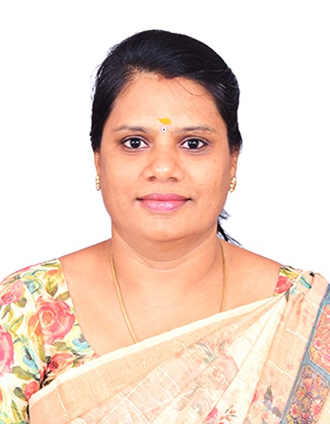
Bibliography

Dr.P.Priyadharshini B.E,MBA,M.E, Ph.D.,

642/29 Ramalakshmi Nagar, priya@psnacet.edu.in
Near Velu Mahal, 9047888831
Chettinaickenpatti (po), AU ID : 9213448
Dindigul (DT)-624 004. AICTE : 1-2657945983

Objective
To obtain a position that will enable me to use my strong technical skills, educational background and ability to work well in the educational institution.
Industrial Experience (03 YEARS 10 MONTHS) ,L&T- ECC DIVISON,CHENNAI.
Teaching Experience (10 YEARS 02 MONTHS) 10th year @ PSNA
S.No | Name of the Institution | Designation | Joining  Date | Relieving Date | Experience
 |  |  |  |  | Years | Months | Day
1. | Larsen & Toubro PVT Ltd, ECC Division – Chennai | Systems Analyst | 15-09-2008 | 11-06-2011 | 3 | 10 | -
2. | P.S.N.A. College of Engineering & Technology (Autonomous), Dindigul – 624 622. | Assistant Professor | 24.06.2015 | Till Date | 10 | 2 | -
Educational Qualification
Qualification | Name of the  Institution/Place | Board / University | Marks % | Class | Year of Passing
Ph.D. | Information and Communication Engineering, Anna University, Chennai |  | - | - | 2025
M.E  (Computer and Communication) | PSNA College of Engineering and Technology. | Anna University Chennai | 8 CGPA | I | 2014
MBA (Technology Management) | ACTech, Chennai (Distance Mode) | Anna University Chennai | 65% | I | 2011
B.E  (CSE) | PSNA College of Engineering and Technology | Anna University Chennai | 71% | I | 2008
HSC | MVM Girls Matric Hr Sec School, Dindigul. | State Board | 85% | - | 2004
SSLC | MVM Girls Matric Hr Sec School, Dindigul. | State Board | 85% | - | 2002
Research Title, Area
Optimization algorithms for reducing delay and traffic in routing for wireless sensor networks and IOT.

Area of Interest
• Internet of Things (IoT)
• Wireless Sensor Networks (WSN)
• Deep Learning (DL)
• Natural Language Processing (NLP)
Book Chapter
Title of the Book Chapter | Publisher | ISBN No | Year
Efficient PHOA Based Routing Network Protocol for IoT-Sem System | Next-Gen Technologies in Computational Intelligence,  CRC Press, Taylor & Francis | eBook ISBN -9781003430452 | 2024
Journal Publication
S.No | Title of the Paper | Publishers | Year, Volume,Issue | ISSN/DOI
1 | Optimizing Pharmaceutical Supply Chains using a Hybrid CNN-LSTM Model for Accurate Medicine Demand Forecasting  Authors: P Priyadharshini, S Keerthana, GK Devi | IEEE - 2025 3rd International Conference on Self Sustainable Artificial Intelligence Systems (ICSSAS) | 2025 | ISSN  979-8-3315-3884-2  DOI  10.1109/ICSSAS66150.2025.11080811
2 | ConvLSTM for Flood Forecasting: A Deep Neural Network Model for Integrated Temporal and Spatial Flood Analysis  Authors: P. Priyadharshini; R. Parvathi; Lijetha C Jaffrin; R. Santhana Krishnan; J. Relin Francis Raj; T. Saranya | IEEE - 2025 3rd International Conference on Inventive Computing and Informatics (ICICI) | 2025 | ISSN  979-8-3315-3830-9  DOI  10.1109/ICICI65870.2025.11069957
3 | Innovative Solar Ironing System: Combining Renewable Energy with Advanced Deep Learning Techniques  Authors: P. Priyadharshini, X. Arogya Presskila, Santhana Krishnan .R, G. Vinoth Rajkumar, Vinoth Kumar Vasanthan, G. Rekha | 2024 4th International Conference on Sustainable Expert Systems (ICSES) | 2024 | DOI:10.1109/ICSES63445.2024.10762993
4 | Traffic and delay aware routing using optimization algorithm for wireless sensor networks  Authors: P. Priyadharshini, Dr S Pavalarajan | Journal of Intelligent & Fuzzy Systems [SCI] | 2023,  Volume 44, Issue 5. | ISSN  1875-8967
5 | LBMM in cloud computing  Authors: R Vasanthi, M Madhu Bharathi, K Sentamilselvan, P Priyadharshini, S Subiramoniyan, P Jenopaul, S Gowdhamkumar | Annals of the Romanian Society for Cell Biology | 2021,  1530-1536 | ISSN  1583-6258
6 | Novel Energy Consumption Using Optimized Genetic Machine (OGA) Learning Techniques  Authors: P. Priyadharshini, Dr S Pavalarajan | Journal of Critical Reviews | 2020,  Volume 7 Issue 13. | DOI  10.31838/jcr.07.13.682
7 | Research on Achieving Data Security with the Cloud Computing Adoption Framework  Authors: P. Priyadharshini, Dr R Adhilakshmi, Dr R Bhaskaran | International Journal of Innovative Technology and Exploring Engineering | 2019 | EID:  2-s2.0-85071743794  Part of ISBN:  22783075  10.35940/ijitee.F1316.0486S419
Personal Detail
Date of Birth : 16-05-1987
Marital Status : Married
Name of the Spouse : Dr.K Suresh. M.E, Ph.D.
Children : 2
Nationality : Indian
Languages Known : Tamil & English

